Testing and Quality Assurance

By: Caleb Stephen

**Objective:**

Ensure the backend functionality and user experience of the Auralis Chrome Extension meets the requirements. The Backend testing was done using pytest.

**Test Types:**

* Unit Tests
* Integration Tests

**Backend Test Cases:**

| **Test Case ID** | **Description** | **Expected Result** | **Status** |
| --- | --- | --- | --- |
| TC-001 | Verify that the initial questions are generated upon web page processing on Auralis’s website | API should return status 200 and correct data | Passed |
| TC-002 | Validate if the backend is appropriately handling user queries relevant to context | API should return status 200 and relevant answer | Passed |
| TC-003 | Verify functionality when invalid URL is received by the backend | API should return status 400 and error message | Passed |
| TC-004 | Validate if the backend is appropriately handling user queries irrelevant to context | API should return status 200 and return a message “couldn’t find relevant answer” | Passed |

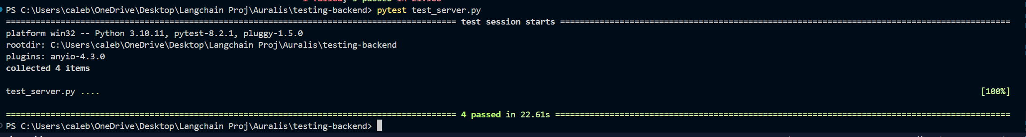

**Objective:**

Ensure the frontend functionality and user experience of the Auralis Chrome Extension meets the requirements.

**Frontend Test Cases:**

| **Test Case ID** | **Description** | **Expected Result** | **Status** |
| --- | --- | --- | --- |
| TC-001 | Verify page processing | Page processing message should be displayed | Passed |
| TC-002 | Verify button click functionality | Button should send a user’s question | Passed |
| TC-003 | Verify content display on load | Suggested questions and answer to the query should be displayed. | Passed |
| TC-004 | Toggle between light and dark modes | When the moon/sun icon is clicked, the respective modes must be toggled | Passed |

**Output:**

TC-001:

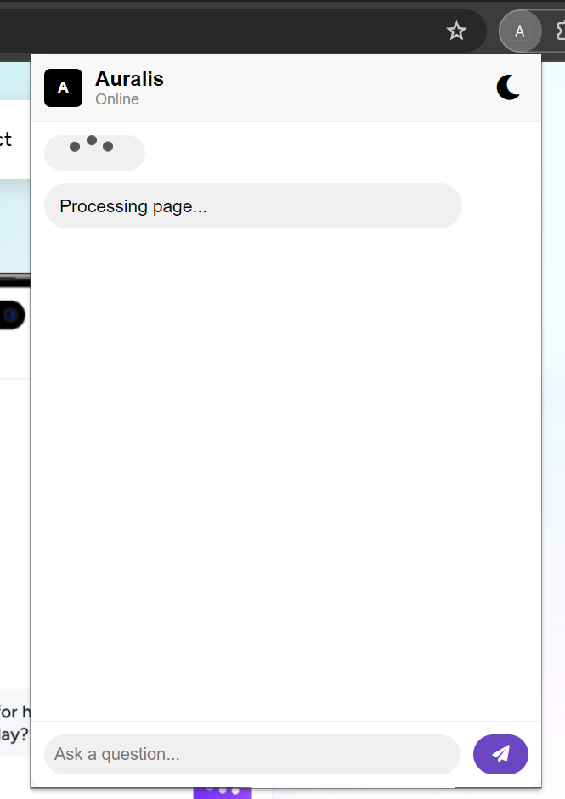

TC-002:

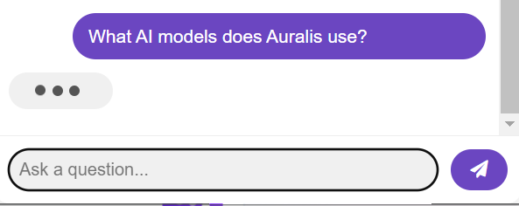

TC-003:

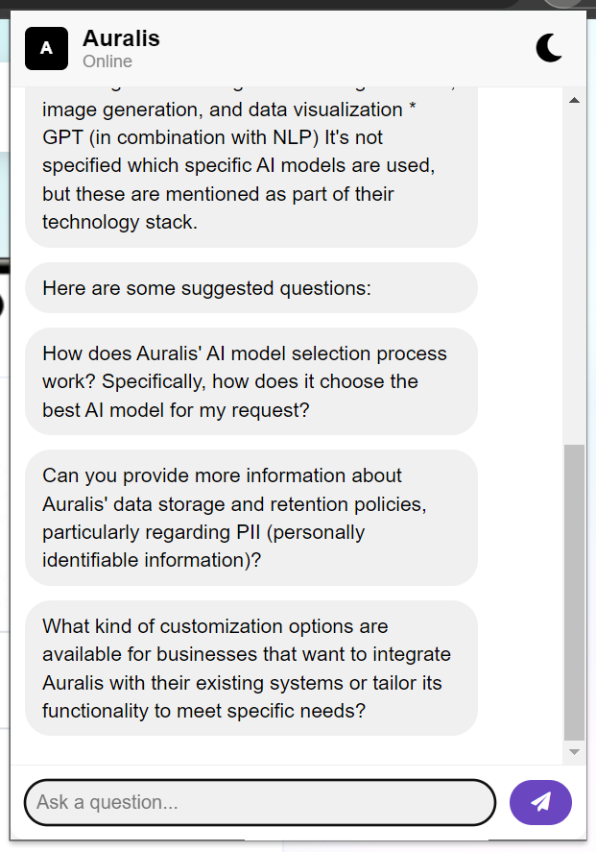

TC-004:

